Overview:
This project focuses on an analysis of Netflix’s movies and TV shows dataset using SQL. The objective is to uncover meaningful insights and answer key business questions through data exploration and query-based analysis. This document presents the project’s objectives, business problems, SQL-based solutions, findings, and overall conclusions.
Dataset:
- show_id
- type
- title
- director
- cast
- country
- date_added
- release_year
- rating
- duration
- listed_in
- description
Schema:
create database p5;
use p5;

CREATE TABLE Netflix_analysis (
show_id VARCHAR(10),
type VARCHAR(10),
title VARCHAR(255),
director VARCHAR(255),
cast TEXT,
country VARCHAR(255),
date_added VARCHAR(50),
release_year INT,
rating VARCHAR(50),
duration VARCHAR(50),
listed_in VARCHAR(255),
description TEXT
);
Data Loading:
LOAD DATA INFILE 'E:/DA/projects/sql projects/2/netflix_titles.csv'
INTO TABLE netflix_analysis
FIELDS TERMINATED BY ','
OPTIONALLY ENCLOSED BY '"'
LINES TERMINATED BY '\r\n'
IGNORE 1 ROWS;
Queries:
1.Count Movies vs TV Shows.
select type,count(*) as total_count from netflix_analysis group by type
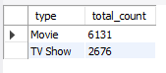
2.Most common rating for movies and TV shows.
select * from (select type,rating,
count(*) as tcount,row_number()over(partition by type order by count(*) desc) as rw
from netflix_analysis group by type,rating)x where rw=1
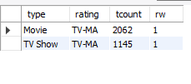
3.List movies released in a specific year (e.g., 2020).
select show_id,type,title,release_year from netflix_analysis where release_year=2020
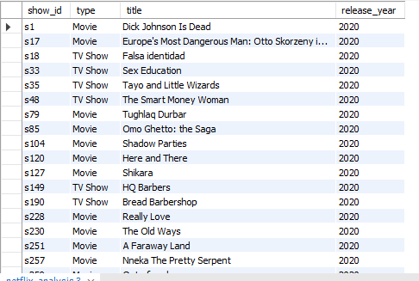
4.Top 5 countries with most content.
select country,count(*) tcount from netflix_analysis group by country order by count(*) desc limit 5
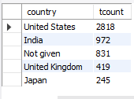
5.Identify the longest movie
SELECT title,duration FROM netflix_analysis
WHERE type = 'Movie'
ORDER BY left(duration,2) desc
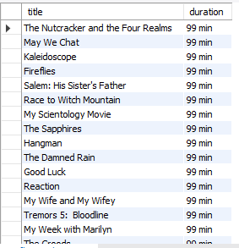

6.Content added in the last 5 years.
ALTER TABLE netflix_analysis ADD COLUMN date_added_parsed DATE;

UPDATE netflix_analysis
SET date_added_parsed = STR_TO_DATE(NULLIF(date_added, ''), '%M %e, %Y');

select show_id,type,title,date_added_parsed from netflix_analysis where date_added_parsed
>=date_sub(curdate(),interval 5 year)
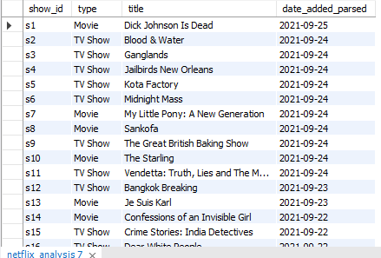

7.All titles by director 'Rajiv Chilaka'.
select title from netflix_analysis where director='Rajiv Chilaka'
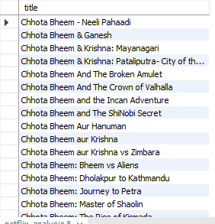

8.TV shows with more than 5 seasons (seasons > 5).
select type,duration from netflix_analysis where type='TV show' and left(duration,1)>5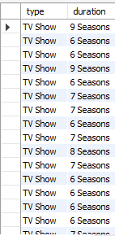

9.Total no of content added
select count(*) as totalmovies from netflix_analysis
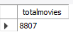

10.year with total content added
select release_year,count(*) as tcount from netflix_analysis group by release_year order by tcount desc
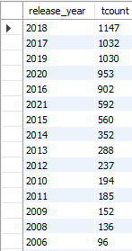

11.List movies that are documentaries.
select title,listed_in from netflix_analysis where type='Movie' and listed_in like '%Documen%'
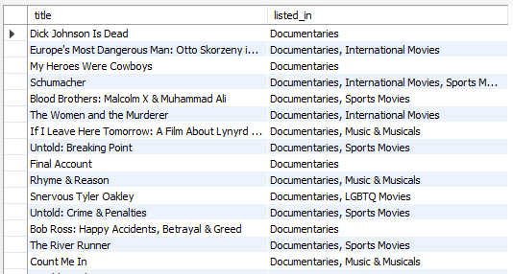

12.Content with no director (NULL).
select * from netflix_analysis where director is null
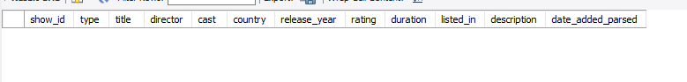

13.How many movies actor 'Salman Khan' appeared in last 10 years
select count(*) as total_movies from netflix_analysis where type='Movie' and cast like '%salman%'
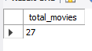

14.country with most content added
select country,count(*) tcount from netflix_analysis group by country order by count(*) desc limit 1
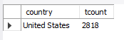

15.Categorize descriptions as 'Bad' if they contain kill or violence, else 'Good'; count each category.
select
case when description like '%kill%' or description like '%violence%' then 'bad'
else 'good'
end as category,count(*) as total
from netflix_analysis
group by category
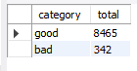

Top 5 recommendations:
- Netflix’s Indian content production peaked between 2019–2021, aligning with the platform’s push for regional diversification and original programming.
- From 2021 Tvshows increased rapidly.so add more content.
- Add movies or tv show that don’t have violence
- Netflix heavily invested in regional content like Sacred Games, Delhi Crime, and Lust Stories during this time.
- Try to add more movies rather than tv show and that are in English
Final Project Summary:
This SQL analysis highlights Netflix’s strong emphasis on drama-based and Indian regional content, steady increase in local production after 2018, and the importance of metadata quality. The insights can help Netflix optimize its content acquisition and improve search personalization.

